**Workflow Functional Document**

|  |
| --- |
| **Application :** NGERP-CENTRA |
| **WorkFlow :** Procurement To Pay |
| **WorkFlow Item Name :** P2P NTA Marketing Campaign |

**Description :**

These P2P files, from the P2P system (Integration) to the Compiere system, are used to import P2P master data to HQ. The P2P masters are then used to create the NTA marketing campaign and update the contribution percentage from the proposal to the NTA campaign.

**Work Flow Process :**

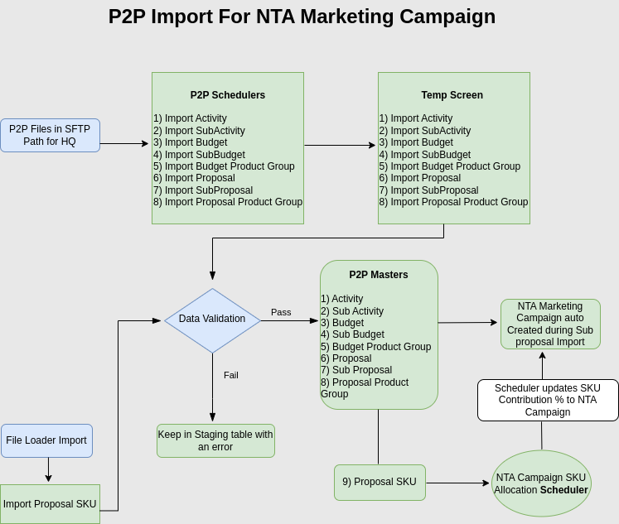

**Bussiness Rules**

* P2P Masters data are imported from P2P system(Integration) to Compiere system.
* The P2P import process is available only at HQ.
* P2P Import Path **P2P/P2C**
* Import file format should be **xls(Excel 97-2003)**
* If the P2P import is in XLSX format, the scheduler will not be able to read this format.
* P2P Import files listed below

i) Import Activity

ii) Import SubActivity

iii) Import Budget

iv) Import SubBudget

v) Import Budget Product Group

vi) Import Proposal

vii) Import SubProposal

viii) Import Proposal Product Group

* Each Import contain unique scheduler, **total P2P import is 8.**
* Once All P2P Scheduler run successfully master data is imported to Main screen.
* If the import file data contains an error, the data will not be moved to the main screen, and an error will be displayed on the temp screen.
* If file is imported sucessfully, the file moved to **Archive** folder.
* If the same file is imported again, it will update the existing data and should not allow the creation of duplicate entries.
* Ways to impot P2P files in HQ

i) File loader Import

ii) P2P Scheduler Import

* P2P Masters are not able to create manually; it should be import only.
* When the subproposal is successfully imported, the NTA marketing campaign is automatically created against the subproposal.
* Import Proposal SKU is manual import through file loader it used to add the product and Contribution % against Subproposal.
* Once the proposal SKU is added in the Proposal screen, the user needs to manually validate the proposal using the 'Validate Proposal' button. Validation is successful when the contribution percentage of the added proposal SKU equals 100. If validation is successful, the 'Verified' checkbox is marked as 'Y'. If there is an error during validation, the 'Verified' checkbox will be marked as 'N', and the error will be displayed as a popup message.
* Once Proposal is verified successfully then the NTA Marketing campaign scheduler is run and update the SKU contribution % from proposal SKU to NTA Marketing campaign master.